**Instructions to set up a GeneMapper microsatellite project**

**Joe Hoffman, june 2011**

**Preparation of sequencing files**

For each run, the CEBITEC will generate 3 folders. You need to organize the files into new folders as follows:

Plate 1, mix 1

Plate 1, mix 2

Plate 2, mix 1

Plate 2, mix 2

etc...

In my case, I have 8 Antarctic fur seal samples genotyped at two Galapagos sea lion primer mixes. Therefore, I set up two new folders entitled 'mix 1' and 'mix 2' and pasted the corresponding .FSA files directly into these.

**To get started in Genemarker**

Open Genemarker

Open data

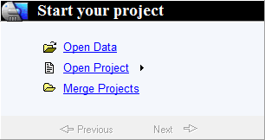

Add the data from mix 1 by selecting all of the .FSA files within the 'mix 1' folder

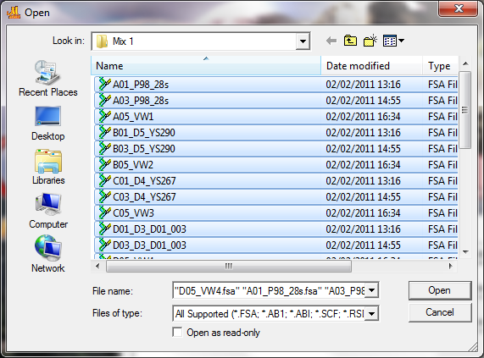

Then click 'open' followed by 'OK'

**To change viewing settings**

To open a display window, click:

-view

-preference

-display settings

You can change the max no. of charts to 96 (one plate)

Max Chart # in page indicates the number of individuals for which profiles will be shown. Three is a good number.

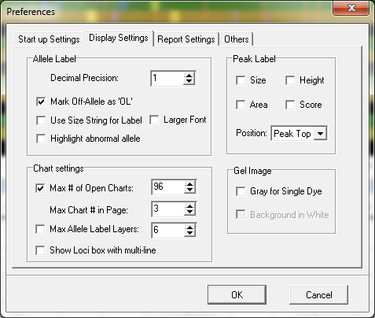

**To visualize all of the samples at the same time**

Right click on the sample in the bottom left hand window and select 'select max'. It'll replace all of the icons with ticks.

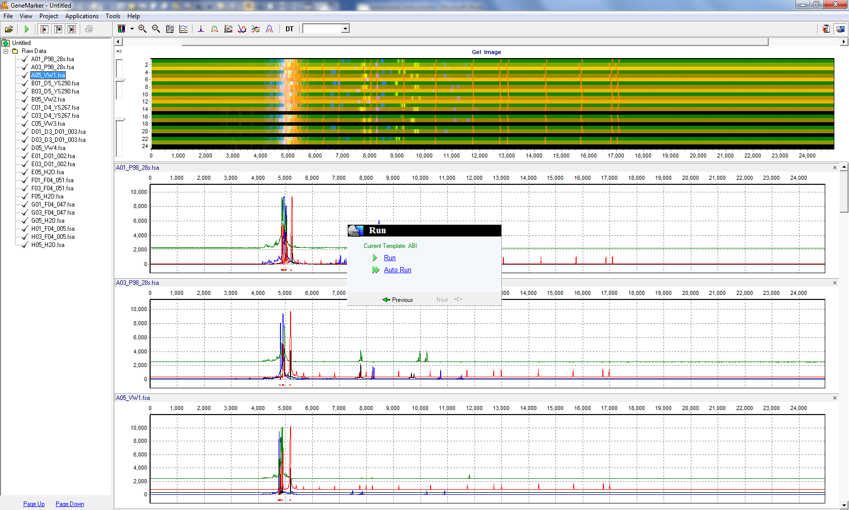

**Start the analysis wizard**

Click on the green 'play' icon

At this point, you can select the panel if it's already been created. Also make sure the correct size standard has been selected.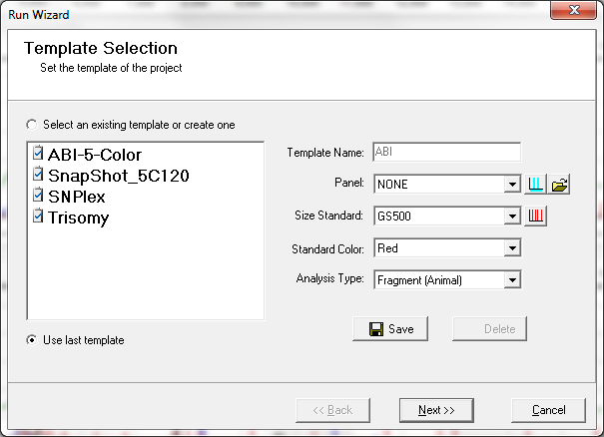

Click 'next' and then use the default settings (see below).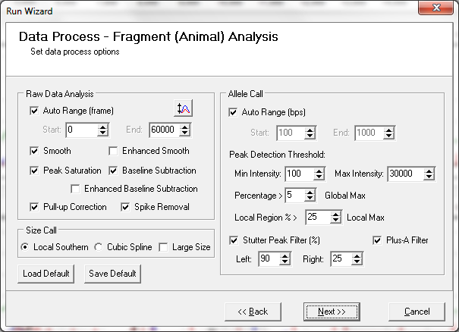

Click 'next' again and then use the default settings (see below).

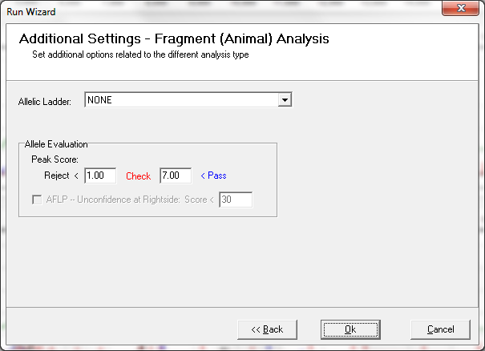

Click 'OK'. It will then analyse the samples.

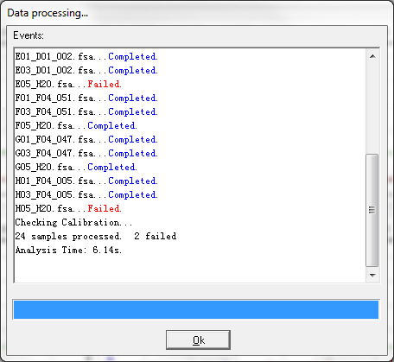

Note that 2 of my samples failed, but they were water (negative controls) and so were expected to fail.

Click 'OK'. A modified screen then comes up.

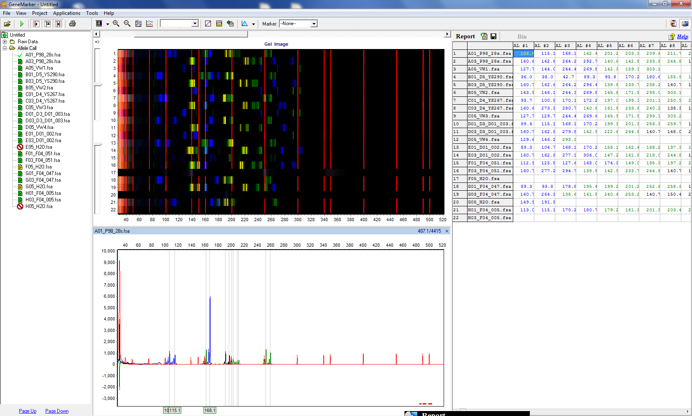

If you've selected the panel, the program will present the allele calls in the right hand window (the 'report window').

Even though we have not yet generated a panel, the program has already attempted to find the peaks and therefore has some data in this window.

In the left window, green indicates that the sample has worked well, yellow indicates that it's not worked so well, and a red crossed circle indicates a failed sample.

In all cases (even when it's green) you should check all of the calls for each sample / locus by eye.

**To set up a panel**

Select the following:

-tools

-panel editor

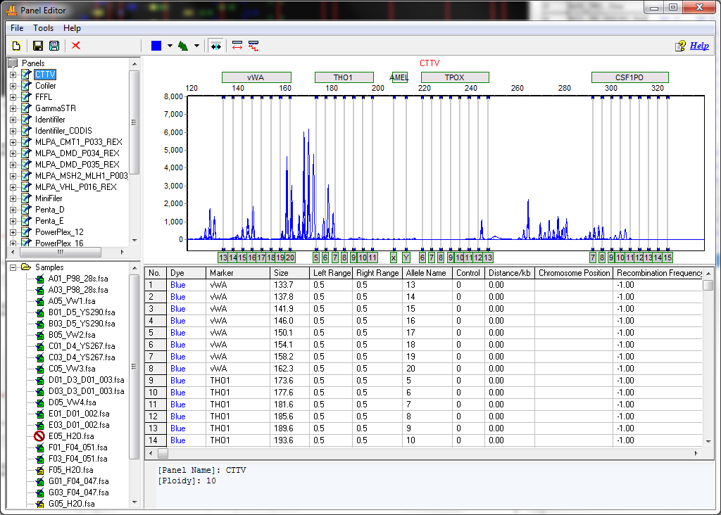

The top left panel shows several default panels. If we create a new panel, this will then appear in this window. Now select:

-file

-new panel

Give it a name. Here, I've included in the name my initials (JH), the species identifier (Antarctic fur seal), and a mix identifier (Galapagos sea lion mix 1).

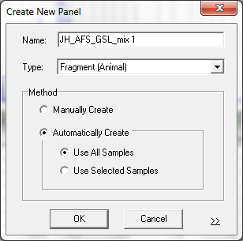

-click OK

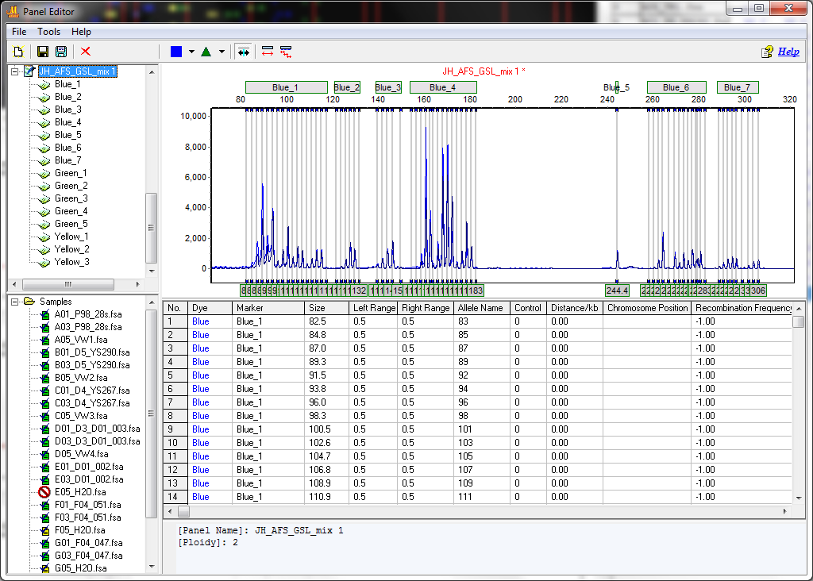

The panels 'Blue_1' etc. in the top left window are useless. Select each of these icons in the top left window and click the red cross to delete them.

NOTE: to avoid deleting the rubbish bins, click 'Manually create' in the dialogue box above.

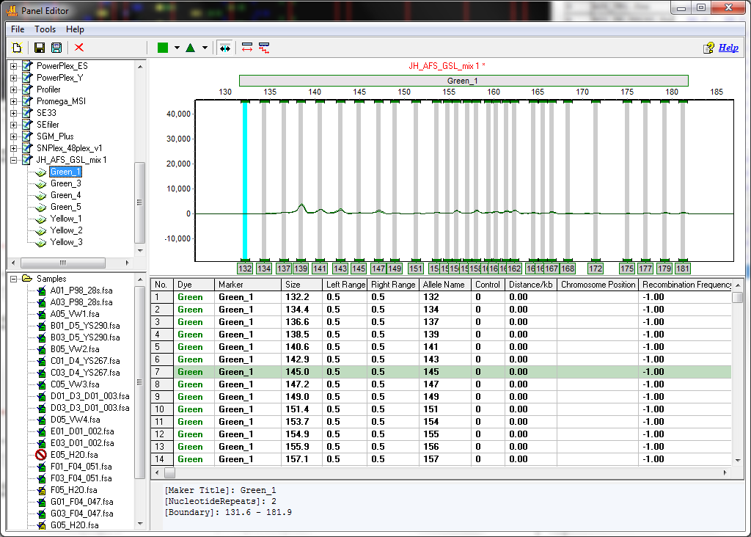

At this point you may need to zoom out. Click the left mouse button and draw a box from right to left. To zoom in, click the left mouse button and draw a box to the right. If for some reason this fails to work, close the panel editor and open it again.

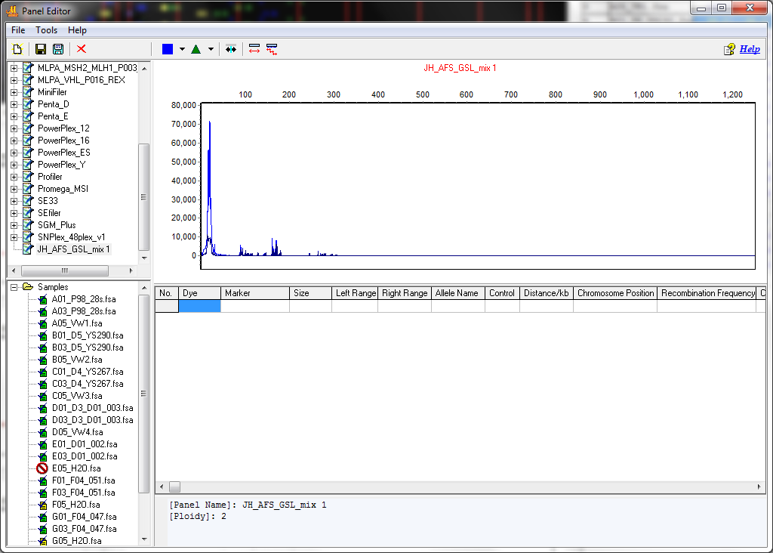

The default shows the traces of all of the individuals for a given dye simultaneously. If you right click in the bottom left window, you can deselect all of the samples and then select samples of your choice. To create the panels, its best to have all of the samples selected.

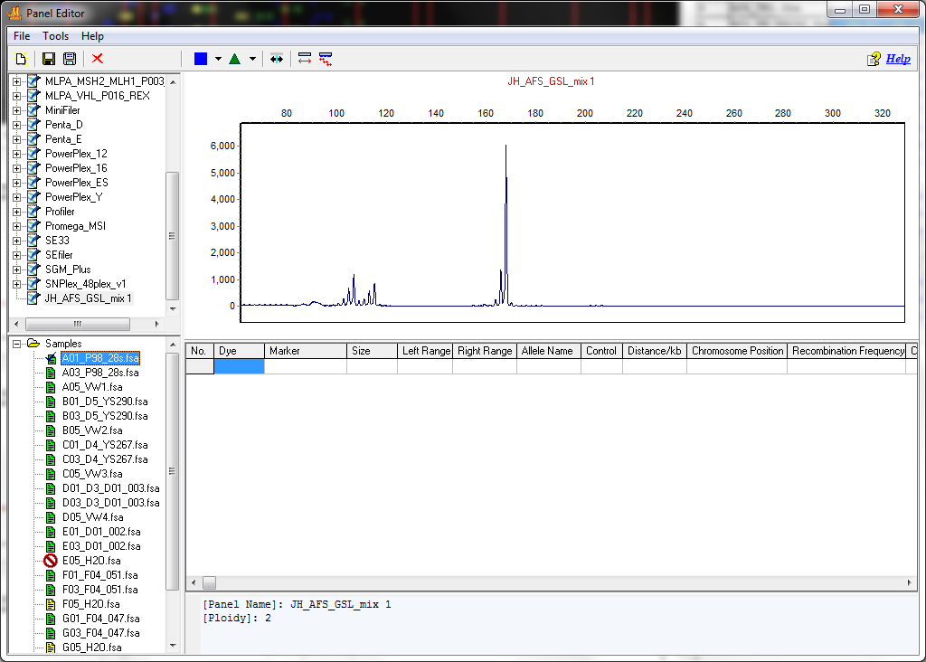

**To set the bins and create the markers**

Start with the first locus (approx 90-200bp)

Select an allele somewhere in the middle of the size range (in this case 127)

Right click on the peak and select 'insert allele'

Give the locus a name ('in this case 'A05')

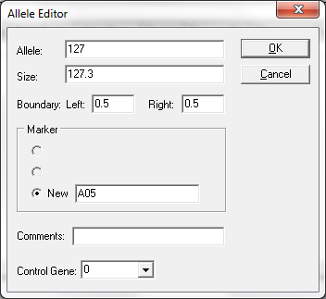

You then see the allele highlighted. In this case, the bin is not directly over the peak itself. To change the bin setting, select the bin and right click, then click 'edit allele' to open the dialog box. Within this, you can change the actual size, in this case to 127.6.

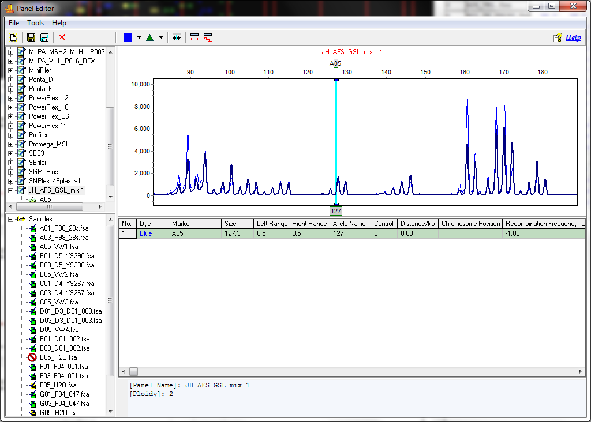

So that it looks like this:

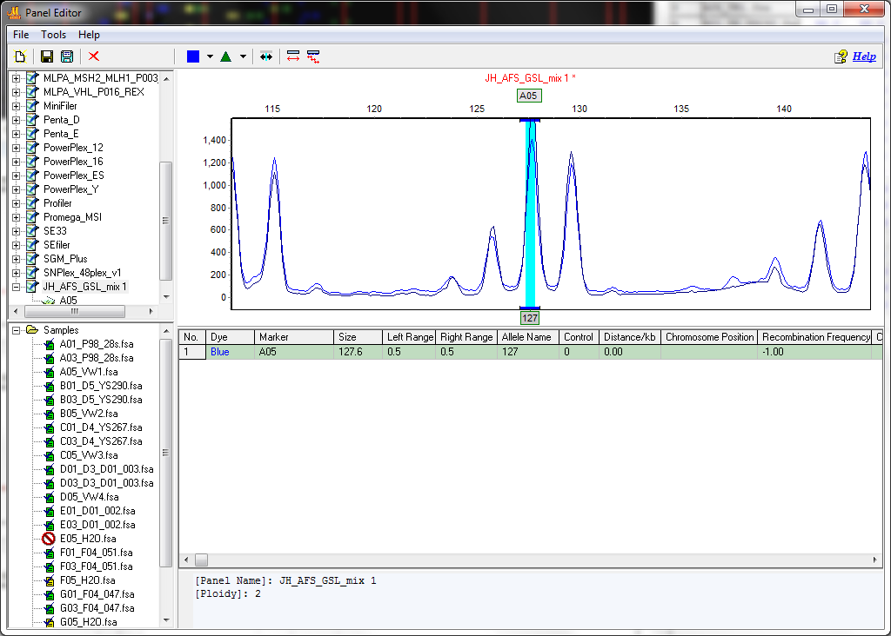

Repeat this for the other allele sizes. You can change the allele names so that they conform to a 2bp periodicity. For now, use the default bin width of 0.5.

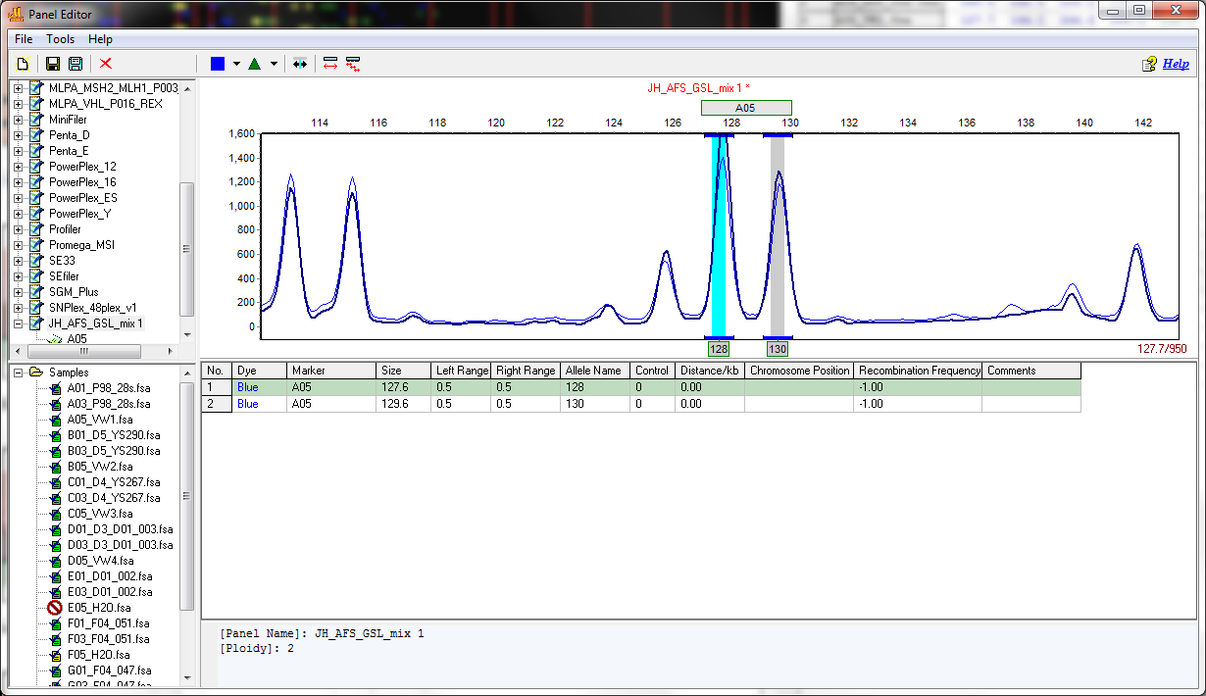

Once the locus is done, the table below can easily be modified to change the allele names, sizes, etc.

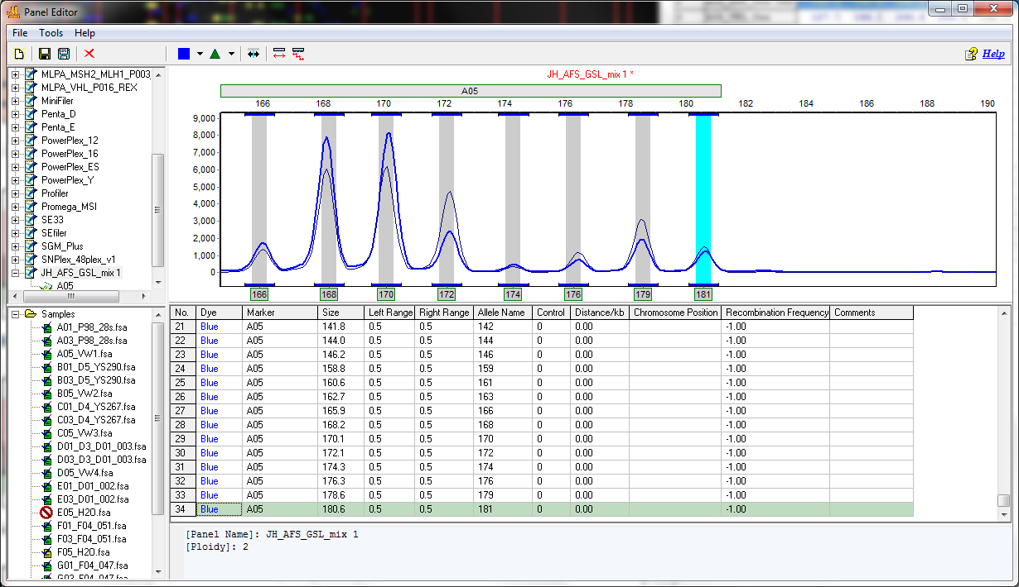

Then proceed onto the next locus for this dye, in this case Pv9 which is larger than A05. When you select the first allele, you need to change the locus name to Pv9. Thereafter, the locus name will remain as Pv9 unless specified.

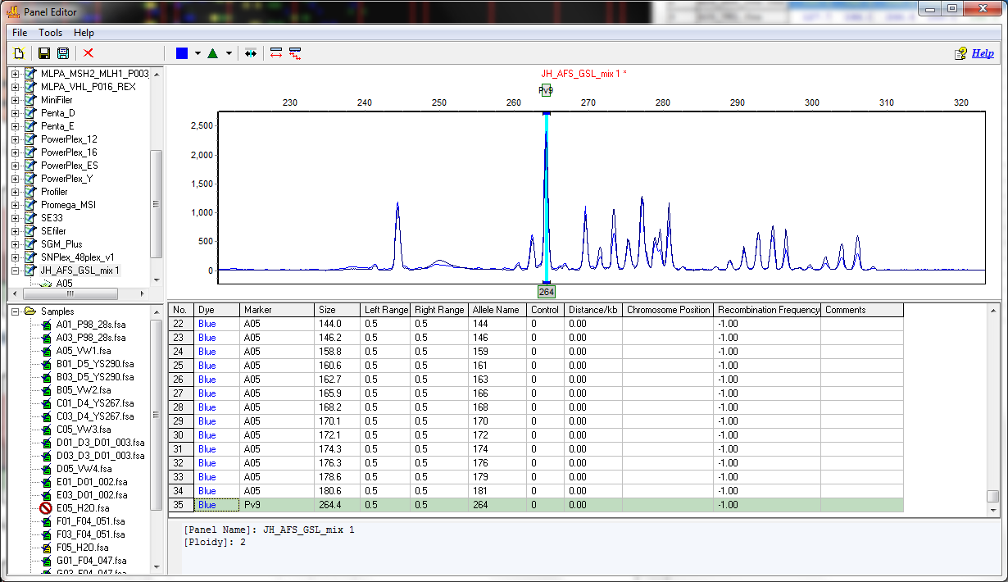

Finally, go through all of the dyes doing the same thing.

**Analyze the samples using the new panel**.

Click the green 'play' button

Change the Panel to the panel to be used and then select:

-next

-next

-OK

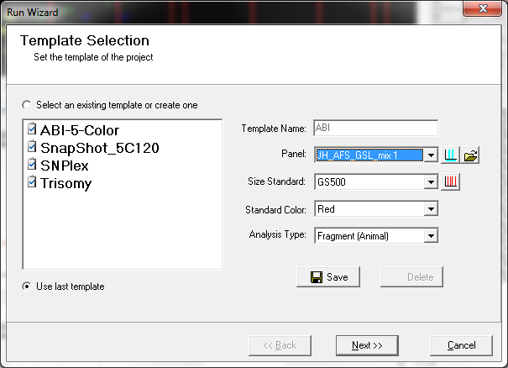

A new window then opens (below). Click 'call size again' and 'apply to all'

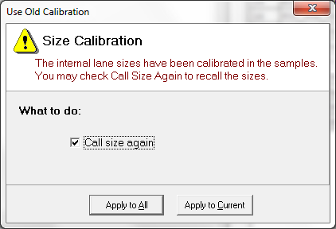

When this window comes up, click 'OK'

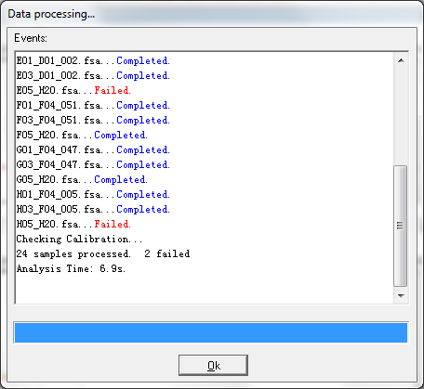

The allele calls are shown in the right hand window. You need to check them all, but at the very minimum check the ones with red crossed circles or with >2 alleles!

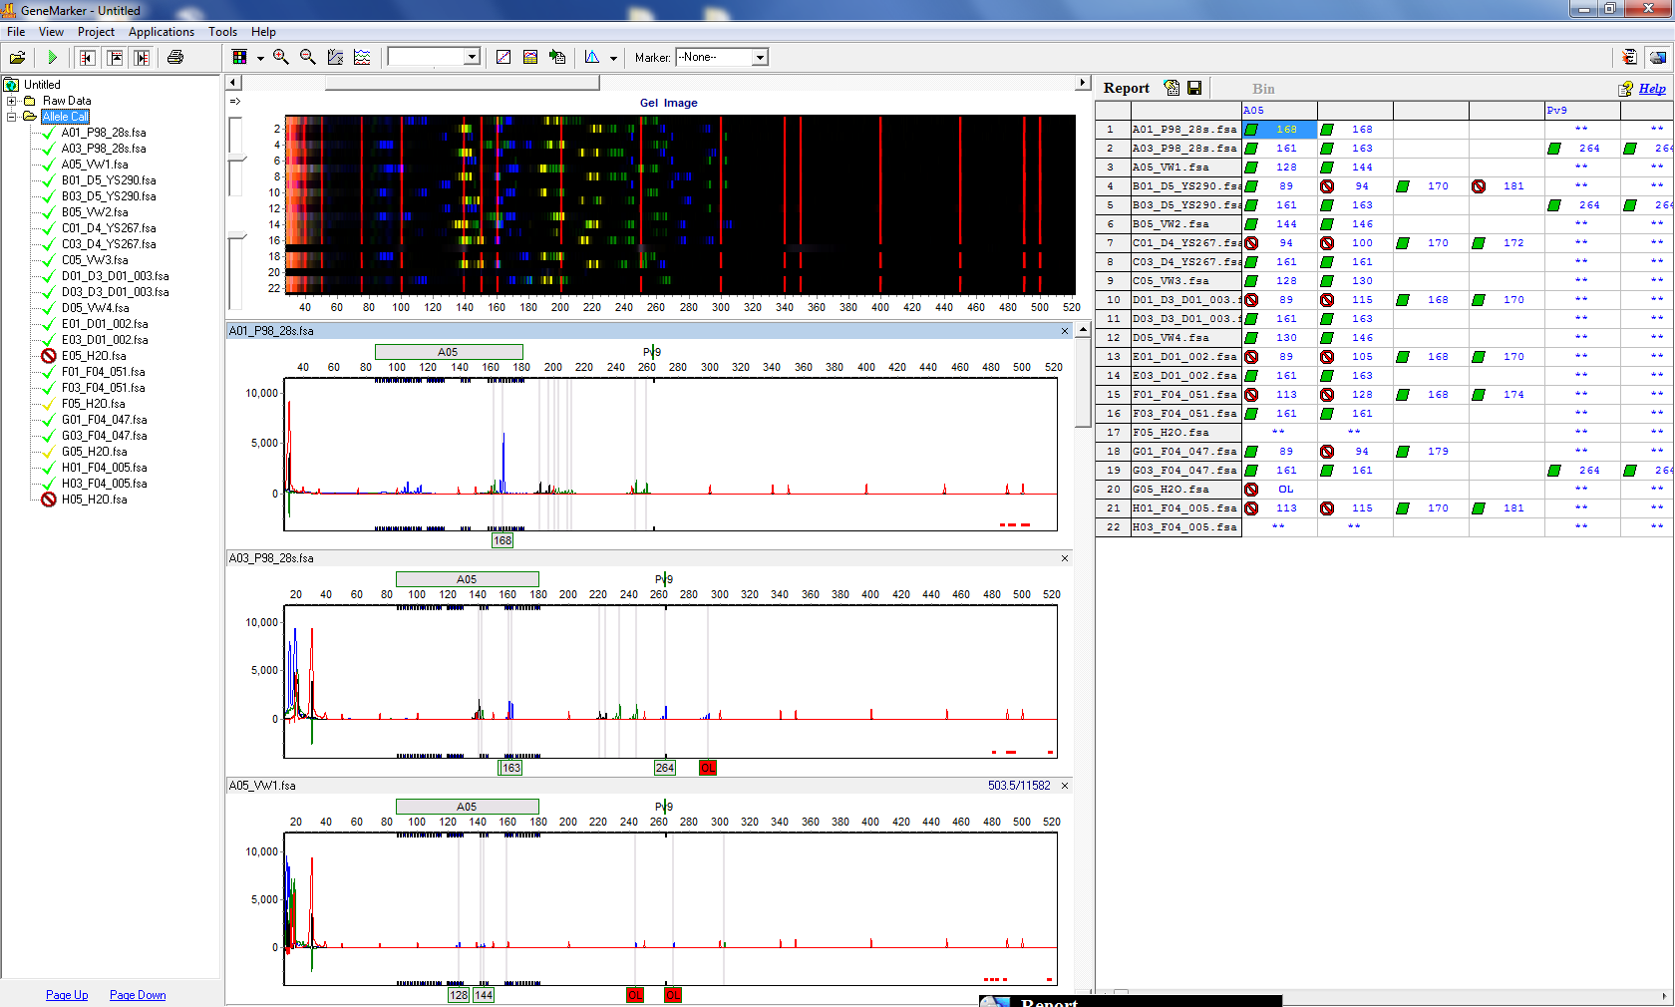

**To check the allele calls**

'Select max' after right clicking in the bottom left window

You can hide the gel image by clicking the 4th icon from the left on the menu bar

Click 'hide all' under the colour icon, then select blue

So we can now visualize 3 samples at a time for only blue

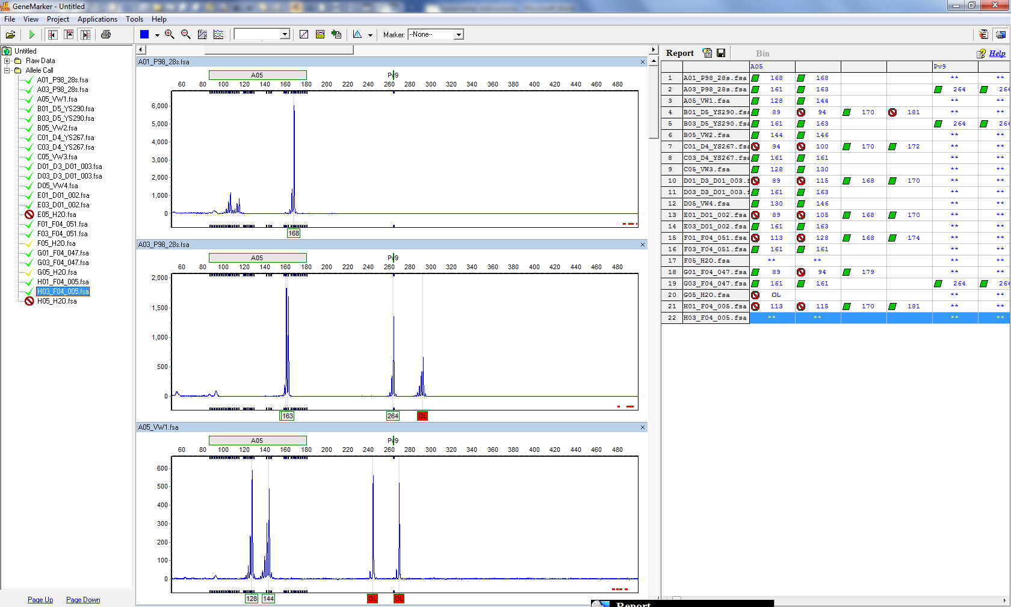

Then you can also select 'A05' under the 'marker' to get only this locus

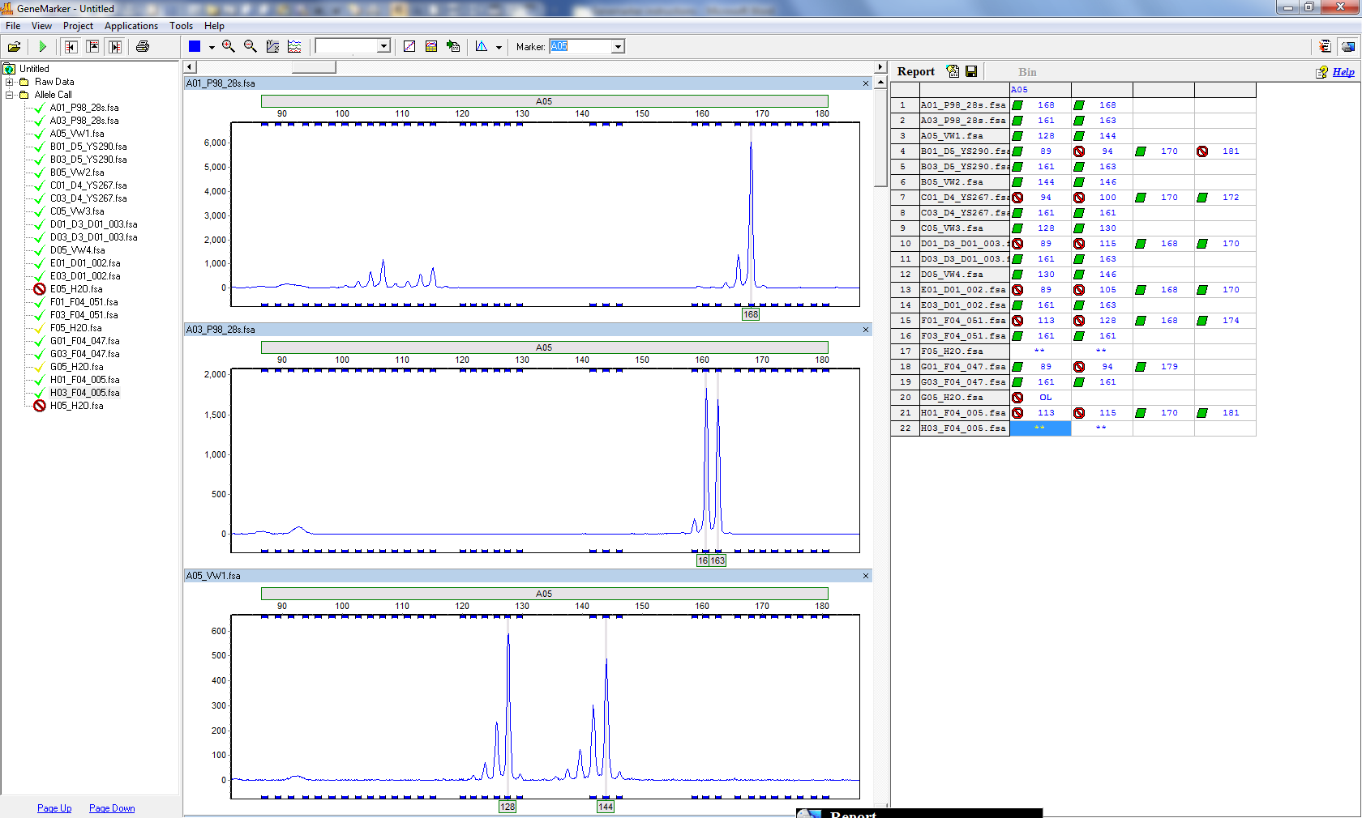

You can then scroll through the samples by dragging the slider on the right hand side.

**To export the data**

Select all of the dyes under the colour icon (if you want all of the loci to be scored)

Click on the report icon (hand pointing towards paper)

Use the default settings. In my case, I prefer to have an 'x' for missing data

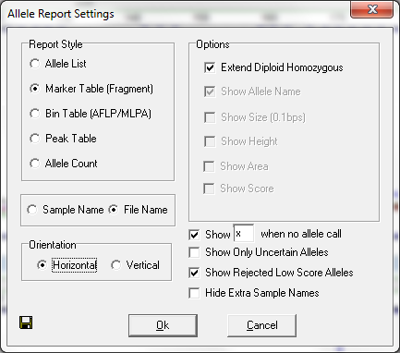

Click on the save icon

Specify the name and location of the file (refer to the plate and the mix in the filename)

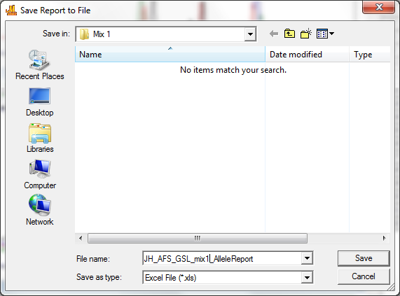

**Save your work**

We will have a different project for each of the two mixes, so save the project in the 'mix 1' folder.

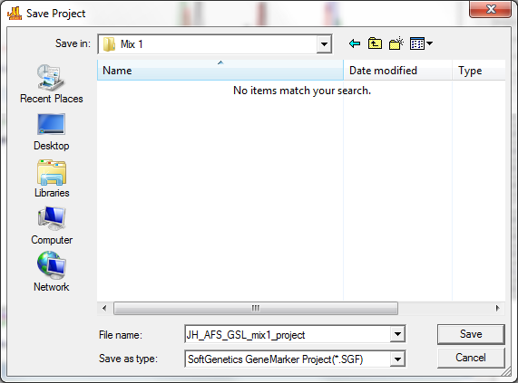

Also, you may want to have the panel file in order to work with the project on another computer. This should be inside the 'Panels' folder of the program, which can be navigated to within Program files. I could not find it within this folder, so I did a search for part of the filename. I then right clicked on the file and selected 'open file location' which allowed me to select and copy the file into the 'mix 1' folder.

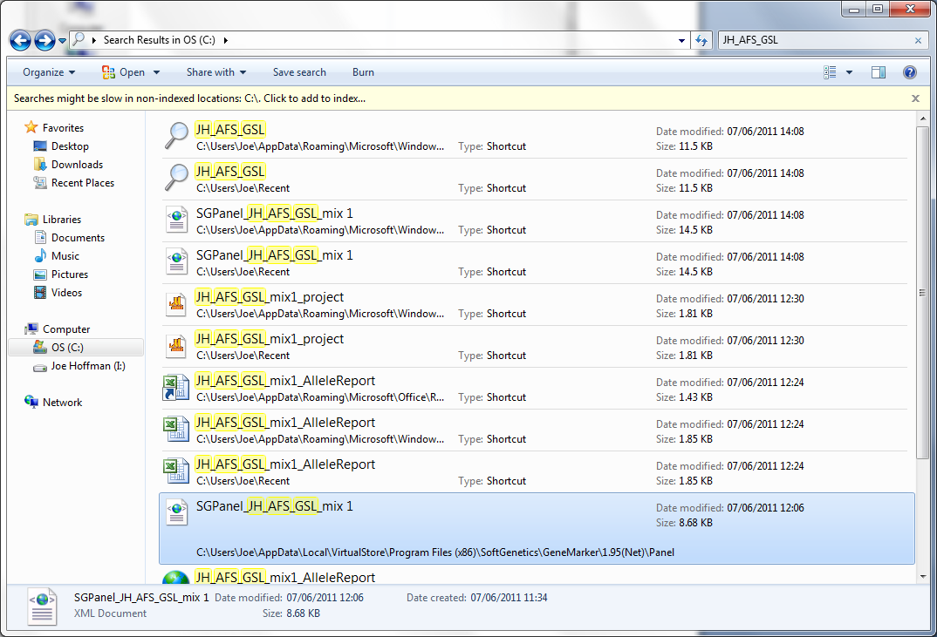

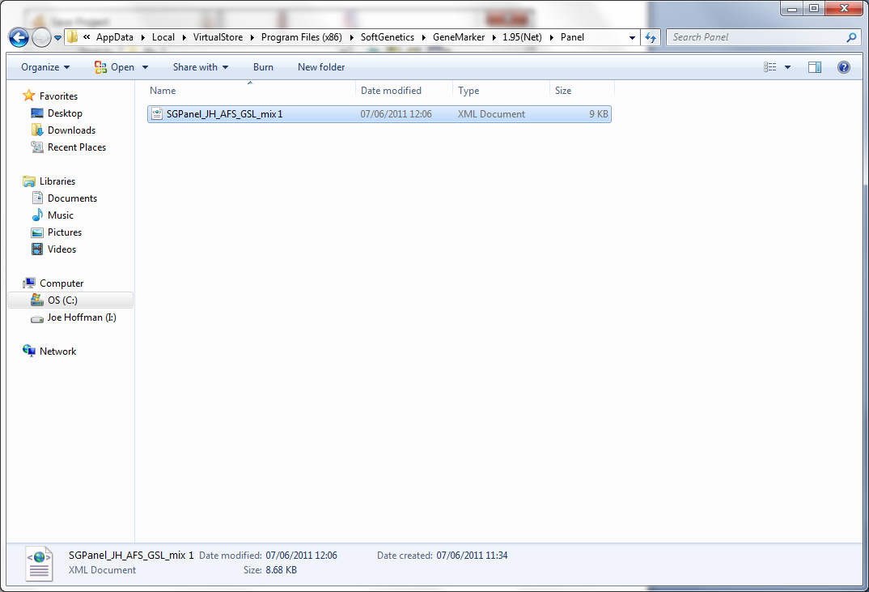

Finally, if you open the 'mix 1' folder, you have all of the necessary files.

